

PO Box 201800 | 1515 East 6th Avenue | Helena, MT | 59620 | 406-444-3115

**VERIZON JETPACK USER GUIDE**

**FOLLOW THESE STEPS TO GET THE MOST OUT OF YOUR VERIZON JETPACK.**

1. Press the **Power button**to turn on the Verizon Jetpack. If the Jetpack does not power on, it may be necessary to charge the device.  
   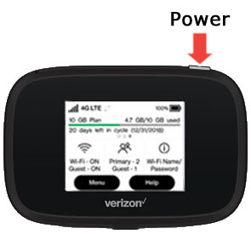
2. Establish a Wi-Fi network connection between the Jetpack and a device:
   1. The Wi-Fi name and password are obtained via the [external LED](https://www.verizon.com/support/knowledge-base-220938/) of the Jetpack.
   2. To connect your device, follow the instructions below for the correct operating system:

**iOS / Apple OS INSTRUCTIONS**

1. From the menu bar, click the Wi-Fi icon (located in the top-right)Macintosh desktop menu bar, Wi-Fi icon
2. Click the preferred network.
3. If presented, enter the Wi-Fi network password, then click **Join**.
4. **System Preferences:**
   1. From the Macintosh desktop, navigate to Apple > System Preferences.
   2. Click Network.
   3. Ensure AirPort/Wi-Fi is the selected network service. (AirPort/Wi-Fi is unavailable unless a module is installed.)
   4. From the **Network Name** dropdown menu, click the preferred network.
   5. If presented, enter the network password then click OK.

## **WINDOWS OS INSTRUCTIONS**

1. From the Windows desktop, tap or click the **Wi-Fi icon** WiFi icon (located in the lower-right, in the task bar).
   1. Alternate navigation: click **Windows icon** Windows icon (lower-left) > **Settings icon** Settings icon > **Network & Internet** > **Show available networks**.
2. From the Wi-Fi section select an available network.
3. Click **Connect**.
4. If prompted, enter the appropriate network security key or username and password then click **OK**.

**FROM THERE, OPEN A WEB BROWSER AND ENJOY!**



*This project is funded in part with Library Services and Technology Act funding from*

*the Institute of Museum and Library Services, administered by the Montana State Library.*