

PO Box 201800 | 1515 East 6th Avenue | Helena, MT | 59620 | 406-444-3115

**T-MOBILE FRANKLIN T9 USER GUIDE**

1. You can find the Wi-Fi Name and password at any time you need. Press the Power/Menu button (indicated in red below) when the display is on (indicated in blue below). The menu will switch every three seconds and show you the Wi-Fi **network name** and **password**.

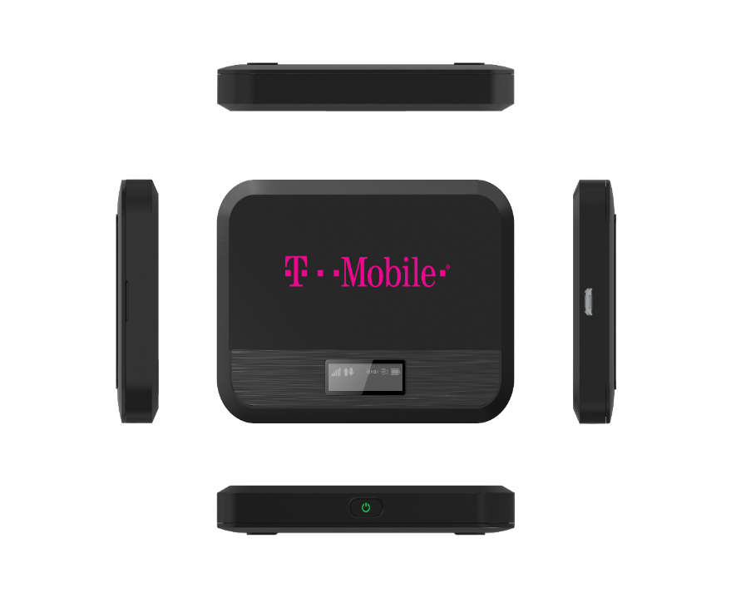

1. **To connect your Wi-Fi device to your mobile hot spot:**

On your computer or other Wi-Fi-enabled device, search for available Wi-Fi networks and select the hot spot network name.

* From a Windows PC:
  + Left-click **Wireless Network Connection** on the taskbar to view available networks.
  + Choose the hot spot network from the list of available networks.
* From a Mac computer:
  + Select **System Preferences > Network > Airport.**
  + Click **Advanced** to choose the hot spot network from the list of available networks.
  + Choose the hot spot network from the list of available networks.
* From an iOS device:
  + Go to **Settings > Wi-Fi.**
  + Choose the hot spot network from the available networks.
* From an Android device:
  + Go to **Settings > WiFi settings.**
  + Choose the hot spot network from the available networks.

Once you have selected the network name, enter the password, then click **OK.**

**FROM THERE, OPEN A WEB BROWSER AND ENJOY!**



*This project is funded in part with Library Services and Technology Act funding from the Institute of*

*Museum and Library Services, administered by the Montana State Library.*