Mobile Hot Spot Checkouts
The library will initially have X hot spots to checkout. These devices are on the Verizon network. Each device comes in a kit with the following items:
- Carrying Case
- Mobile hot spot device
- Charging cable
- Set of instruction sheets
The checkout rules are:
- One device per person at a time
- No temporary cards
- 7 or 14-day checkout with no renewals
Overdue fines will be X.

Turning the hot spot on and off
The hot spot has a battery in it that will give several hours of use if it is charged. If the batter is low, plug the charger cable into the charging port on the device and then into the wall.
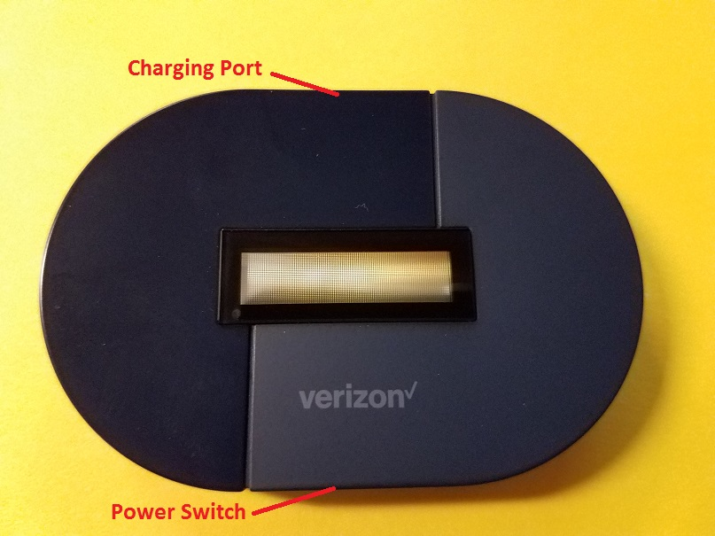
To turn it on, press and hold the power switch for 3-4 seconds. The display will come on. After a few seconds, it will show on the screen Verizon 4G LTE and a battery meter. Once this is shown, you can connect devices to it.
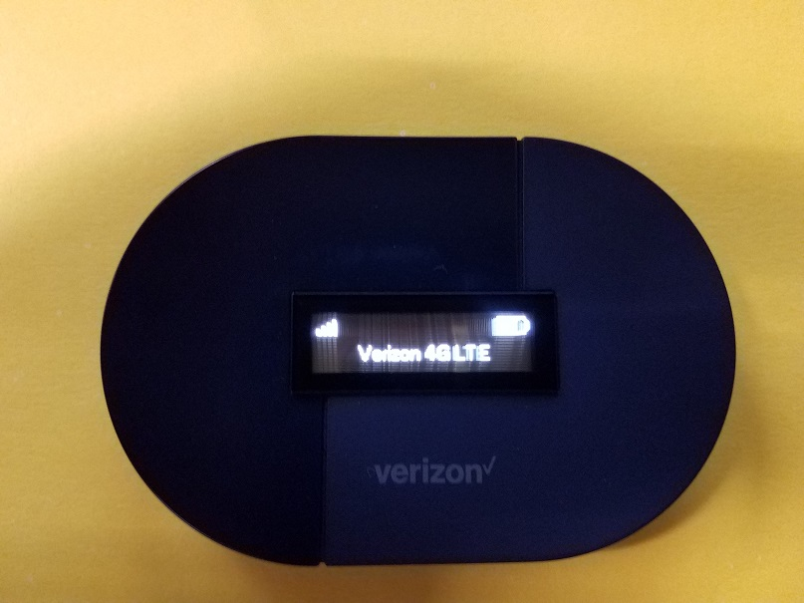
To turn the hot spot off, press and hold the power button for 3-4 seconds until the display shows GOODBYE.

Connecting Devices
Once the hot spot is on, you can connect devices to it. On the device you want to connect, search for a wireless network called:
ENTER NETWORK HERE
When you connect to it, it will ask for a password. The password is:
ENTER PASSWORD HERE OR DELETE IF NO PASSWORD
The password is case sensitive, so make sure you do not capitalize anything.
You can connect up to 8 devices per hot spot. Keep in mind that the more devices you have connected, the slower the service will be.
Since the hot spot is dependent on a signal from the Verizon network, you may not always have a fast, reliable connection. On the screen of the hot spot, check the signal meter. The more lines that are showing, the better the signal will be. If you are having issues with the hotspot, try moving it to a different location in the building, or if you are outside, try moving around.
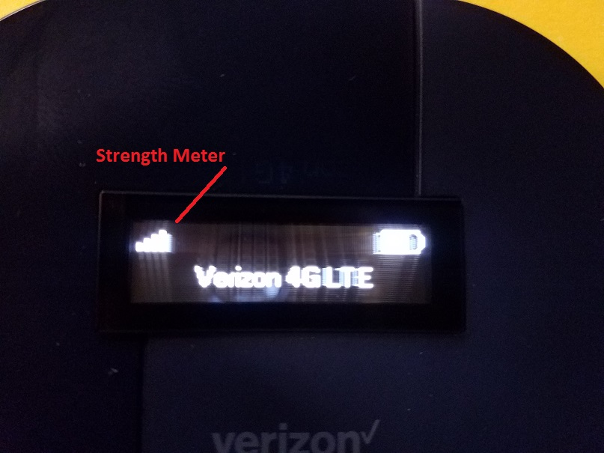

Troubleshooting
Sometimes, devices will have issues connecting to the hotspot. If there are any problems connecting, try these steps:
1. Reboot the device. This usually resolves most issues.
2. Disconnect and reconnect to the hotspot wireless network.
3. On the device, turn the wireless off and on.
4. Forget the network, restart the device, and then re-join the network.
5. Before connecting to the hot spot network, close all browser windows.
6. After connecting to the hot spot network, try going to a website you have not visited recently.
7. Try restarting the hot spot.
Not every device will be able to connect. There are many reasons why not everything will be able to connect.
If you continue to experience issues connecting to the device, contact the manufacturer of your device, or search for solutions on their websites.
Do not contact Verizon Wireless for support. They will not be able to assist.
If you have any other concerns, contact the library at 406-XXX - XXXX, but keep in mind that staff will only be able to suggest this list of troubleshooting steps.

