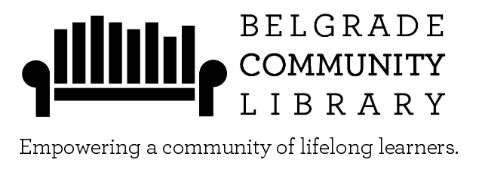
106 N BROADWAY
BELGRADE, MT 59714
(406)388-4346
www.belgradelibrary.org

LIBRARY LAPTOP POLICY

Any patron with a Belgrade Community Library (or BridgerNet) card in good standing (not expired and no fines over $10.00) may check out a laptop computer using a current photo ID and patron’s library card (the ID and library card will be held at the circulation desk while the laptop is checked out).

Laptop use is restricted to the main floor of the Library. Laptops should not be taken into the restrooms. Laptops may be checked out for two consecutive hours. A laptop may not be renewed.

Laptops are available when the Library is open. Laptops should be turned in fifteen minutes prior to closing. Laptops cannot be borrowed 30 minutes or less before the Library closes.

A signed Library Laptop Loan Agreement must be on file at the circulation desk. The borrower who checks out the laptop is responsible for damage until the laptop is returned to the circulation desk.

Patrons may not leave the laptop unattended. Leave the laptop with a Library staff member at the circulation desk if you must exit the Library while the laptop is checked out to you. The Library is not responsible for any lost files nor will any files be saved on the hard drive.

Laptops must be returned to a Library staff member and not just left on the counter when returned. Please report any technical problems or equipment malfunctions to Library staff.

106 N BROADWAY
BELGRADE, MT 59714
(406)388-4346
www.belgradelibrary.org

LIBRARY LAPTOP LOAN AGREEMENT
- I accept full responsibility for the laptop and accessories I am borrowing. I will reimburse Belgrade Community Library for the cost of repairing or replacing this laptop or accessories if they are damaged or lost while checked out in my name.
- I agree to comply with Belgrade Community Library’s rules regarding computer use.
- I understand that the circulation period is two hours or less, depending on the time the laptop is checked out.
- I agree to pay $1.00 per hour overdue fees if I do not return the loaned laptop within the 2-hour circulation period.
- I will not download or copy software to the laptop nor deliberately attempt to modify the laptop in any harmful or malicious way.
- I will not remove the laptop from the main floor of the Belgrade Community Library. All laptops must stay inside the building. I agree that I will lose my laptop borrowing privileges if I attempt to exit the building with a Library laptop.

A BORROWED LAPTOP IS FOR LIBRARY USE ONLY. DO NOT LEAVE THE LAPTOP UNATTENDED.

Your signature below indicates that you recognize your responsibility in the care and custody of any laptop you borrow from Belgrade Community Library.

________________________________________________________________________
SIGNATURE DATE
________________________________________________________________________
LIBRARY CARD # PHONE #
Children under the age of 16 are required to have the signature of a parent/guardian in order to check out the Library laptop.
________________________________________________________________________
PARENT/GUARDIAN SIGNATURE DATE

