

PO Box 201800 | 1515 East 6th Avenue | Helena, MT | 59620 | 406-444-3115

**T-MOBILE ALCATEL LINKZONE USER GUIDE**

1. To start the device, hold the Power key for 3 seconds until all LED indicators illuminate in blue. If the hot spot does not power on, check the battery light to make sure the device is charged. The light should be blue. Three lights indicate that the hot spot is fully charged.

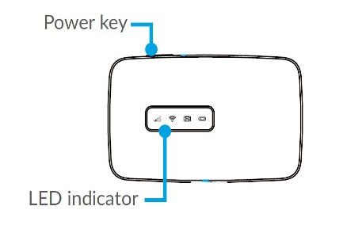 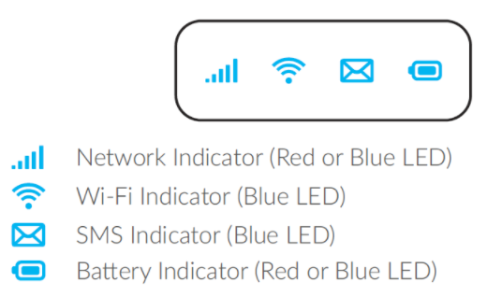

**\*PLEASE NOTE:** To ensure that you get the most out of your device, please observe the following recommendations for using the Alcatel Linkzone hot spot:

* Do not press the WPS key located near the power button. This will log you out of the current WiFi network.
* Do not press and hold the power button and the WPS button at the same time, as this will cause your device to restart.

1. To connect to your mobile hot spot, search for available Wi-Fi networks on your computer or other Wi-Fi-enabled device and select the device name provided by your library.
   1. From a Windows PC:
      1. Left-click **Wireless Network Connection** on the taskbar to view available networks.
      2. Choose the device name (provided by your library) from the list of available networks.
   2. From a Mac computer:
      1. Select **System Preferences > Network > Airport**.
      2. Click **Advanced** to choose the device name (provided by your library) from the list of available networks.
      3. Choose the device name (provided by your library) from the list of available networks.
   3. From an iOS device:
      1. Go to **Settings > Wi-Fi**.
      2. Choose the device name (provided by your library) from the available networks.

* 1. From an Android device:
     1. Go to **Settings > WiFi settings**.
     2. Choose the device name (provided by your library) from the available networks.

1. Finally, enter the password provided by your library and click **OK**.

**FROM THERE, OPEN A WEB BROWSER AND ENJOY!**



*This project is funded in part with Library Services and Technology Act funding from the Institute of*

*Museum and Library Services, administered by the Montana State Library.*