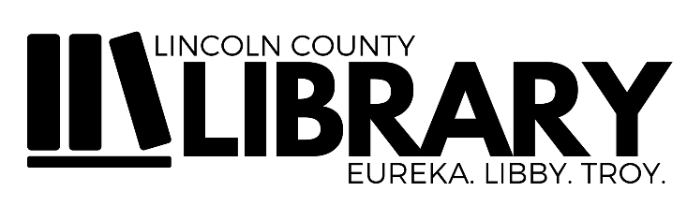

MOBILE HOTSPOT BORROWER AGREEMENT

Use of a library hotspot is subject to the terms and conditions set forth in this Checkout Agreement, and by checking out the hotspot, you agree to the following:

- I understand that the hotspot can only be checked out by a Lincoln County Library cardholder who is at least 18 years of age.
- I understand that the hotspot can be checked out for 14 days. It must be returned to a staff member inside the Library by the due date, with all included cables and original packaging. The hotspot may NOT be returned to the outdoor book drop. If the hotspot has not been returned by its due date, data service will be terminated, and the hot spot will become unusable.
- I understand that Lincoln County Library has no control over and cannot guarantee the availability of hotspot service or continuous service or speed of the connection.
- If I do not return the hotspot unit to Lincoln County Library in good working condition and free from damage, with all included parts and packaging, I will be charged a $200 replacement fee. If individual parts are damaged, stolen or lost, replacement fees will be incurred as follows: hotspot $100, case $15, adapter $5, USB cord $5.
- I understand that I am responsible for monitoring what my children and other minors’ access or view while using the hotspot.
- I understand that I must comply with the Service Providers Acceptable Use Policy, Privacy Policy and Terms of Use, as well as Lincoln County Library’s Internet Use Policy. It is my responsibility to read and abide by these policies and to comply with all Federal and State Laws.
- I understand that wireless networks “Hotspots” are freely accessible and may be unsecure. I understand that the Service Provider, Lincoln County Library, and their officials and employees are not responsible for any files, data, confidential or personal information accessed, transmitted, lost or damaged as a result of using the hotspot.

By signing below, I acknowledge that I have read the above terms and conditions and agree to abide by them. If I do not abide by these terms and conditions, I acknowledge that my checkout privileges may be revoked.

Signature Date

Printed Name Library Card #

The Library does its best to provide clean, secure, and fully functional equipment, but is not responsible for charging the device or for any unforeseen hardware or software failure. Library staff will make every effort to document any existing damage; however, if a borrower discovers any pre-existing damage, the borrower should notify library staff as soon as possible. Failure to notify the Library of existing damage limits the borrower’s ability to dispute charges for damage discovered upon the device’s return. The borrower acknowledges and agrees not to hold Lincoln County Library responsible for any personal injury, inconvenience, or expense incurred as a result of using library equipment.

HOTSPOT LENDING PROGRAM

The COVID-19 pandemic has greatly exacerbated the digital divide in Montana, which is why the Montana State Library has invested in a hotspot lending program. In partnership with T-Mobile and Verizon, the Montana State Library has provided hotspots to Lincoln County Library. This is a one-year pilot program. Continuation will be assessed by the Lincoln County Library Board of Trustees at the end of the one-year contract.

BORROWING GUIDELINES
- Checkout period: 14 days
- Adult (18+) cardholders may checkout
- 1 hotspot per cardholder/household at a time
- A cardholder/household must wait 7 days upon returning a hotspot unit before checking one out again
- No renewals
- Borrower Agreement must be signed before hotspot is issued to a patron

GENERAL GUIDELINES
- Coverage depends on the Verizon network so the location of the hotspot and congestion of the network may affect user experience.
- All components of the hotspot units must be returned together at the Circulation Desk. They may not be returned in any outside returns.
- Hotspots are deactivated if overdue or if excessive data is used
- Use of the hotspot is subject to the terms of the Library Internet Use Policy
- Hotspots are not filtered, and it is the user’s responsibility to use the device in a responsible manner and not for any unauthorized, unethical, or illegal purposes
- Parents/guardians are responsible for the use of the hotspot by minors
- Any attempt to alter data or the configuration of the hotspot is strictly prohibited, and many be considered an act of vandalism and subject to full replacement cost value
- The library reserves the right to revoke checkout privileges if these guidelines are not met

DISCLAIMER
Lincoln County Library is not responsible for personal information shared over the internet or for information and websites accessed using this device, or any misuse, harm or any other result due to the use of the hotspot

FEES
Hotspots are free to borrow. Replacement charges will be incurred if the hotspot is lost, stolen or damaged: Hotspot $100, Case $15, Adapter $5, USB cord $5, or Entire kit: $200 (kit + 1-month service)

