Library - Federations

Training – state aid funding – guidance
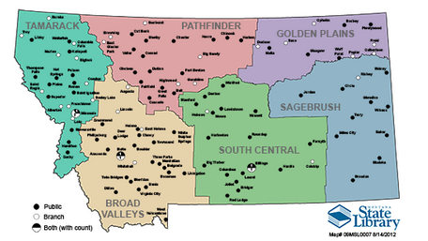

Federations receive funding through the Coal Severance Tax monies that the state receives. This money is divided amongst federations using a formula that is based upon population and evenly dividing the funding. ARM 10.102.5102 gives the specific formula.

Our library federation is: _______________________________
Federation coordinator’s name: __________________________
email: _________________ phone: ________________________
Federation meetings are usually held on____________________________________________________

For more information about federations and state aid funding: http://msl.mt.gov/library_development/consulting/federations/default.asp

