UVa Claude Moore Health Sciences Library  Pocket Response Plan (PReP)™  Revised 04/16  INSTITUTIONAL CONTACTS  (area code 434)  National Network of Libraries of Medicine (NN/LM): 1-800-DEV-ROKS  Preservationist:(Alderman Library)  Lyrasis: 800-999-8558 (24/7 consultation assistance)  Belfor: 804-342-7444  Medical Center  924-8324  Office of Risk Management  924-3055  Emergency Command Center  982-3634  Health System Media Office  924-5679  Finance & Administration  924-8425  Dean of Medical School  924-5118  Student Affairs (Medical)  924-5579  Dean of the Nursing School  924-0063  Student Affairs (Nursing/Undergrad)  924-0141  Student Affairs (Nursing/Grad)  924-0141  Hospital Security  924-5048  Facilities Management  924-2267  Environmental Health & Safety  982-4911  Housekeeping  982-4656  Systems Control  982-4685  ILLiad (interlibrary loan): 800-567-7401  EBSCO (journals): 800-633-4604  Rittenhouse (books): 800-345-6425 ext 114  ClinicalKey: 443-949-9442  OVID: 919-452-9417  UpToDate: 800-998-6374, | DISASTER TEAM  Agency Administrator: In consultation with Incident Commander, determines operational strategies following a disaster or service disruption. – Arnold  Communications Coordinator; coordinates the execution of the COMMUNICATIONS PLAN. – Barker/Wilson  Historic Materials Coordinator: Coordinates all preparedness & response activities for unique or hard to replace materials. – Cavanaugh/Bowden  Interlibrary Loan Coordinator (for libraries that designate ILL borrow as a core service): coordinates and performs all ILL borrow activities from remote location. - Davis  Immediate Response Coordinator: responsible for ensuring that front line staff are able to consistently and effectively carry out response procedures. – Hiserman/Wilson  Access to Online Content Coordinator: works with publishers to resolve online access issues following a disaster or service disruption. – Lord/Son  Facilities Liaison: communicates with Facilities following a disaster. – Reitz/Carter  IT Coordinator: coordinates all IT related issues. – Moody/Denton  Incident Commander: Coordinates the execution of the CONTINUITY OF SERVICES plan. Coordinates all aspects of preparedness & response and creates a disaster ready culture. Coordinates tabletop exercises, after-action reviews, and situational reports. – Wilson/Ragon  Library Leadership Transition: If the Library Director is unable to perform the duties of the position for any reason, responsibility is assigned to:  Dan Wilson: general library operations, collections, space  Bart Ragon: information technology, specialized services (IS, TEC, Hist Coll) | COMMUNICATIONS PLAN  Staff: If there is a possibility of the University closing, all staff should call 924-SNOW or 243-SNOW. If the University cancels classes, non-designated staff should not report to work. Members of the Service Continuity Team should assume their responsibilities. If there is no advanced warning, the Incident Commander will contact members of the Library Disaster Team. The Incident Commander may also choose to activate the Phone Tree.  Public:  Voicemail update: The Incident Commander will change the voice mail message on 924-5444 by calling…  The message should provide status information and ways patrons can access the library’s online resources and get assistance, either Ask A Librarian or chat. Hiserman is backup.  Library’s web page: The HSL home page will be used to announce emergency info and re-direct patrons to assistance. The Incident Commander will update the library’s home page by creating a post on Moore Library News. Moody is backup.  Social networking sites: Communications Support -social media (Barker). Feed from home page automatically populates in HSL Twitter account.  Communication with the Media: the Agency Administrator (Arnold) or designee is the only person authorized to speak with the media. Info must be cleared by the HS Media Office.  Worst Case Scenario:  If possible, post closing information on door.  Cabinet gathers at home of library director.  Activate phone tree. |  | CONTINUITY OF SERVICES PLAN  (Coordinated by the Incident Commander, Monday through Friday, 9am to 5pm)  Access to online content:  1. Vendors: The Access to Online Content Coordinator (Lord) troubleshoots reported access problems to individual titles. Bartczak and Son backup.  2. Network: The Information Technology Coordinator (Ragon) troubleshoots network issues. Moody and Son are backups.  Lord:  Bartczak:  Interlibrary loan: The Interlibrary Loan Coordinator (Davis) processes borrowing requests from home if power is available at home and at the library. If necessary, calls UNC ILL for back-up, and notifies NN/LM at 1-800-338-7657 to have DOCLINE lending requests de-activated.  Davis:  Library Email: Communications Support-chat/email (Denton) schedules staff to check the library’s Reference email account. Son is backup.  Denton:  Son:  Access to Library’s Print Collection: In the event that the Internet is down, patient care personnel can access the Library’s print collection by contacting Health System Security. All core textbooks and reference materials are located in the lobby. The core textbooks are located on the far wall and the reference books are located in the alcove next to the Service Desk. |  | SELECTIVE LIST OF RESPONSE PROCEDURES  TORNADO  Watch: monitor weather reporting stations online and via the weather radio.  Warning: announce via intercom that a warning has posted. Instruct everyone to move away from windows.  POWER OUTAGE  If the power is off at any time for longer than 15 minutes, or if it is dark outside when the power goes off, initiate closing procedures immediately. Check elevators to see if anyone is stranded. Check all areas of the library for patrons who may need help; take flashlights to assist people to leave if the building is dark.  MEDICAL EMERGENCY  Call 911. Announce on the intercom that medical assistance is needed in the [state location].  EARTHQUAKE  DROP, COVER, and HOLD ON. Do not evacuate the library until shaking has stopped and there are no dangers (downed power lines, broken gas lines, etc.).  BOMB THREAT  Get as much information as possible, such as location of device, when it will go off, what it looks like, why it was placed, etc. Listen for environmental clues as to location of caller. Call 911 and follow instructions.  SHOOTER  Take cover.  HAZMAT INCIDENT  Use the intercom to notify patrons and staff of the need to shelter in place. If necessary to  close off air system, shelter in Staff Lounge and use plastic to cover intakes and doors. Post signs if there is time.  REQUEST FOR CONFIDENTIAL INFORMATION  Inquiry: Contact supervisor  Subpoena: Contact supervisor  Search Warrant: Provide access and contact supervisor  Request for Access to Library Computers: Contact IT Director
UVa Claude Moore Health Sciences Library  RESCUE & RELOCATION  Revised 04/16  PRIORITY LIST FOR COLLECTION RECOVERY  (See floor plans at right)  High Priority:  Historical Collections: (see priority list in third column)  Core Textbooks  Reference Collection  Core Journals  Low Priority:  Books, general collection  Journal collection | Floor Plans/Locations of Collections  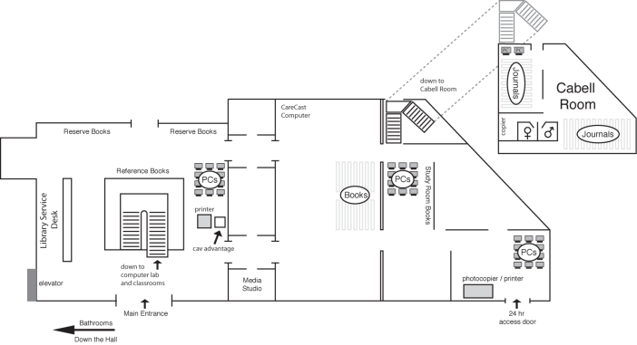  Reference (alcove next to Service Desk)  Detmer Room  (Kerr White Collection)  Journals  (Lower level)  (First Floor)  Core Textbooks  Books  Second floor and Cabell Room  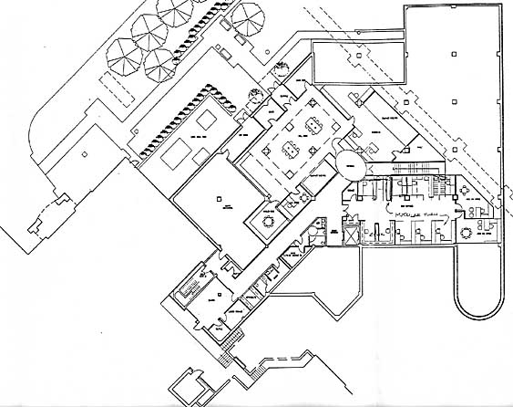  Historical Collections (Basement Level) |  | HISTORICAL COLLECTIONS RESCUE LIST BY PRIORITY |  | RELOCATION STRATEGY  Historical Collections: Store  Detmer Room: Store  Print Journals: Store  General Collection of Books: Store  Core Textbooks: Relocate  Reference Collection: Relocate  Library Computers: Relocate/Store  Library Records: Relocate  Office/Work Space:  Library Director  Assoc. Dir. Collections & Library Services  Assoc. Dir. Knowledge Integration Research & Tech.  Medical Education Librarian  Digital Initiative Librarian  Office Manager  Hospital & Community Services Librarian  IT Director  Metadata Services Assistant  Research & Data Services Manager  Service Desk Manager  Stafford Act  “It will help libraries in need relocate so they can keep serving the public in the wake of a flood or other emergency. Libraries are vital information hubs, and in the aftermath of a disaster, libraries take on an even greater community role, providing free and easy access to technology and essential information.” – Senator Jack Reed

