Disaster Table Top Exercise #1

- Choose someone to collect notes during discussion;
- Use the worksheet enclosed to be sure you complete the full assignment
- Review all the materials in this packet
- Read through the scenario before you open your individual envelopes

Scenario

You are all staff at a small public library in Cleveland, Montana. It is the afternoon of Saturday, March 2nd, you’ve had a lot of snow the past few weeks, and now it is warmer and raining hard. Your very popular annual Dr. Seuss Birthday Party has attracted the usual large group of young children despite the inclement weather. It’s about 2 pm and the library is open until 4 on Saturdays, and closed on Sundays. Just as you hand out the cupcakes, someone comes in to announce that the river is flooding and half of town is now cut off, homes may be underwater close to the river; parts of town are without power. The Library is high and dry and has power and the Internet access and phone line at the library are working.

Rain is predicted to continue for at least another 10 hours.

Your task is to discuss what the library needs to do and to decide together what to do immediately, what needs to be done in the next hour, in the next 2-3 hours and what you will be doing on Sunday. Here are some guidelines:

- What concerns do you have for your patrons that are in the library at the time of the flash flood? How do you keep them safe?
- Imagine what the resources you have at the library that can help your community. Make as exhaustive list as you can – think of the perfect small library as you create this list, but make it realistic too.
- Who do you need to contact? Use the list provided to guide your discussion.

Find the map enclosed that shows the layout of your town and provides more details about the flood. Also enclosed is a list of community resources that you, as the library director, would know about. Consider this information as you deliberate.

Photo: livinglocarb.com
Table Top #2 N

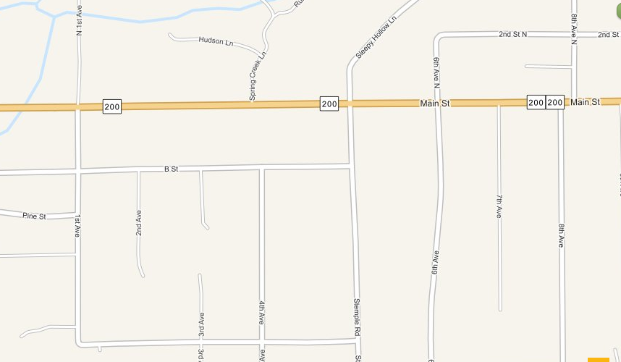
library

This map shows the route of the flooded river through town. The library is uphill from the flood and in no danger.

The nearest hospital is 30 miles west of town. The fire station and nearest police/sheriff station are also on the west end of town. The entire west end of your town is cutoff by the raging water.

Most businesses are on East Main Street and not yet affected by the flood. The school building at the corner of 1st and Hwy 200 is under water.

Roads to the east are passable, but very threatened; it isn’t clear if they will remain safe to travel for much longer. It will take at least 40 minutes for any police and medical personnel to make it to your town from the east.

Table Top #2

Resources available in your community:

There are 3 nurses with their families at the library for the Dr. Seuss birthday party
The town fire chief lives near the library
There is a veterinarian that has an office across the street
The school bus garage is east of town 4 miles
Businesses on Main Street include a fuel station, hardware store, grocery store, fishing outfitters, restaurant, and motel
Cell service is working for now
The highway garage is east of town and there is some equipment in that garage; one of your staff has a brother who works for the highway department

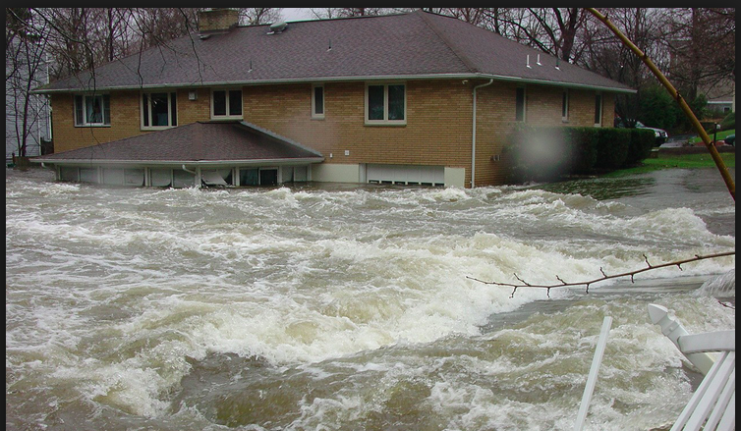

photo: NOAA
Personal details for envelopes – each person gets one (or two)

You are a librarian helping with the program when the flood occurs. You have a teenaged son who was at band practice at the school today. He isn’t answering his phone.

You are a member of the library staff, but not working today. You usually are on ski patrol, but the warm weather has closed the ski center down for the weekend. You have a current first aid certificate and some survival supplies at home, including a portable generator, candles, extra batteries. You live northeast of the library a short distance away.

You are the library director and at the library when news comes in about the flood. You know that it is important to keep calm, and to keep your patrons safe. You went to a training where you learned that it is often the best response to shelter-in-place. You begin to take a count of the people you have in the library and then the fire chief calls to ask if you can take more people in.

You are a parent of two children who brought your neighbors’ kids with you to the library today. You call your neighbor and they tell you that they are cut off from the library but safe. You can’t get home.

You are a parent of a child with cystic fibrosis that requires daily medication and breathing treatments. You realize that you brought an inhaler but no nebulizer and no meds because you didn’t intend to be gone long. But now, you cannot get home. Your child will be okay for a few hours, probably.

You are the fire chief next door to the library and you are contacted by the sheriff dispatcher and asked to assess the situation on your side of town, to set up a road block deterring any west bound traffic from driving into the flooded area and to set up a temporary shelter. You reach 3 volunteers on the east side of the town to assist you to set up the roadblock. There are already cars backed up on Main St. turning around near the flooded area. You have a radio and are in contact with other responders working on the west side.
Scenario # 1 WORKSHEET

What is your library’s response to the Flash Flood?

What are our concerns for my patrons and staff?

What are the resources we have at the library:

Who do we need to contact?

Be specific as you describe your response:

Immediately:

Within the first hour:

Within the first two-three hours:

The next day:

