Disaster Table Top Exercise #2

- Choose someone to collect notes during your discussion;
- Use the worksheet enclosed to be sure you complete the full assignment
- Review all the materials in this packet
- Read through the scenario before you open your individual envelopes

Scenario

You are on staff at a medium-sized public library in Red Timber, Montana. It is the afternoon of Friday, July 2nd; your Lewis & Clark Days’ events are well underway and every motel in your town is booked up solid. It’s 10 am and already the computer stations are filled with teens, not all of them are known to you. Your storytime program - outside - just started. You have Lewis & Clark re-enactors encamped on your lawn attracting lots of tourists. Suddenly, your building starts to shake, some small windows shatter, books fall off from shelves and you realize that this is an earthquake. Then, the power goes out.

Everyone inside tries to get outside. Once outside, you look for your six staff: all accounted for and unharmed. The storytime kids and families appear unhurt, but frightened. Emergency providers are arriving on scene and setting up triage. Your library building looks intact except for a few broken windows. Everyone is outside the library.

You overhear a sheriff’s deputy say that the earthquake has struck a region covering a large area and that your town is on the perimeter of the damage –not the worst.
The weather is clear and dry and temps are hot for the next week. Cell phone service is still working, you get power restored within a few hours; but intermittent outages continue for the next few weeks. Internet is restored when the power is on. The library has air conditioning, one meeting room, two bathrooms, and a kitchen.

Your task is to discuss what the library needs to do and to decide together what to do immediately, what needs to be done in the next few hours, in the next day or so and what you will be doing a week from now and beyond. Here are some guidelines:

- What concerns do you have for your patrons that are in the library or on your lawn at the time of the earthquake? How do you keep them safe? How do you help them recover?
- Imagine what the resources you have at the library that can help your community. Make as exhaustive list as you can – think of the perfect medium-sized library as you create this list, but make it realistic too.
- Who do you need to contact? Use the list provided to guide your discussion.

Find the map enclosed that shows the layout of your town and provides more details about the flood. Also enclosed is a list of community resources that you, as the library director, would know about. Consider this information as you deliberate.

Table Top #2 N

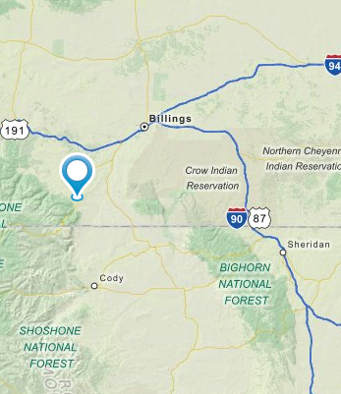

This map shows the region affected by the earthquake. The red explosion graphic shows the epicenter. Sheridan has sustained the worst damage with loss of life; Cody is also in bad shape, few buildings are structurally stable there. Your town has no loss of life, but roads and bridges were damaged and many homes are not habitable. It takes weeks to restore power across the region, and only the road to Cody remains passable. The other roads don’t open up for at least a week. Your water supply and sewage are all intact.

Your library building proves to be safe with no serious structural damage.

The nearest hospital is 40 miles away in Billings, but there is a clinic in town that also survived intact. There is no power at most homes and businesses in the area.

Table Top #2

Resources available in your community:

Town police (12), Sheriff and 20 deputies
Medical Clinic – no overnight beds
City Hall is next door – the building is also not harmed
County social services – social workers
Fire department with a paid chief and 30 volunteers – their building is near the clinic and put into service as a temporary hospital
12 paid paramedics, 15 volunteer EMTs, 3 ambulances
Several nurses and doctors who live in town
3 churches with community halls, kitchens, bathrooms
Three dozen tourist-related businesses: motels, restaurants, gift shops
An architectural firm with a structural engineer on staff
2 Veterinarians; a Humane Society Shelter
Several large ranches and vegetable/fruit farms
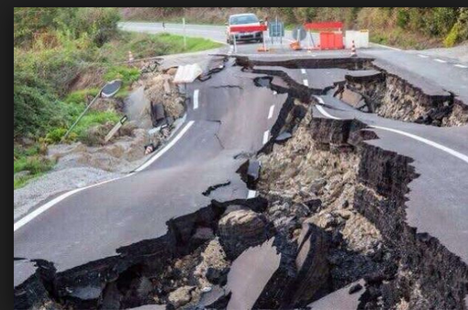
Highway road equipment and garage
Girl Scouts, Boy Scouts, 4H
Hardware store; building supplies
County Fair grounds
3 school buildings
2 grocery stores
Local food shelf
A trucking company with 4 refrigerated trucks

Personal details for envelopes – each person gets one (or two)

You are a librarian presenting the kids program when the earthquake occurs. You have family visiting that were heading into the epicenter of the earthquake for an day long outing. You watched them leave a few hours ago and you cannot reach them to confirm that they are okay.

You are a member of the library staff, but not working today. You are retired from the local search-and-rescue team. You have a current first aid certificate and some survival supplies at home, including a portable generator, candles, extra batteries. You live around the corner from the library and your home seems to have suffered no damage.

You are the library director and at the library at work with the earthquake strikes. You know that it is important to keep calm, and to keep your patrons safe. You went to a training a few years ago where you learned that it is important to keep others calm and to account for all survivors, especially children. You begin to take a count of the people you had at your story time.

You are a parent of two children who brought your neighbor’s kids with you to the library today. You call your neighbor and they tell you that they are cut off from the library but safe. Your home is not accessible because of damage to roads and bridges.

You are a parent of a child with severe asthma that requires daily medication and breathing treatments. You always come prepared, but your child’s nebulizer has to have power to operate. You are both unharmed, but the dust and panic stirred up by the earthquake is already causing your child to start wheezing.

You are the Police Chief and you sit on the library’s board. You’ve been to training where you learned about the roles that libraries often plan during a disaster. Once you have addressed immediate threats to your community and set up an incident command center in City Hall, you consider how the library next door can serve as a communications hub and temporary shelter for your community.
Disaster Scenario #2

DAY THREE

The predicted hot weather has gotten much worse. Daytime highs are now 105 degrees.

The Police Chief asks the library to work with Red Cross to receive family refugees from Cody. FEMA and the Red Cross will set up large tents for sleeping in a park next door to the library, and they will arrange meals at a school nearby, but it is too hot for the displaced families to stay in the tents all day and the school doesn’t have air conditioning.

The Red Cross will manage shelter operations, but your air-conditioned library is the only place for families to spend their days. You are told to expect at least 200 people and that they will be staying for at least one full week, maybe longer. Your library’s meeting room capacity is 60 and you have two bathrooms.

Your community has come to rely on the library to repower their cell phones or to get power for medical devices and to access the Internet. You are already at capacity, with people lining up for these services.

How will you manage this influx of families from Cody?

Meanwhile, the community is desperate for information – to reach out to family, to find friends and neighbors who were away during the earthquake, to hear about when services will be restored or how to go about getting back into their homes. The grocery store shelves are empty, people are depressed, and the hot weather and unpredictable after shocks are putting everyone on edge.
Scenario # 1 WORKSHEET

What is your library’s response to the Earthquake?

What are our concerns for patrons and staff? For the community? For the greater region?

What are the resources we have at the library:

Who do we need to contact?

Be specific as you describe your response:

Immediately:

Within the first few hours:

Within the first day or two:

In the next week and beyond:

