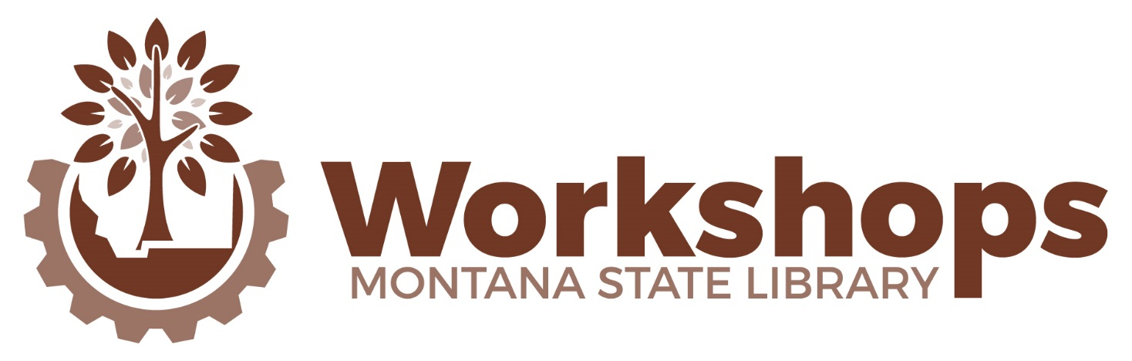
Fall – 2017 – Bozeman – SCHEDULE-AT-A-GLANCE
 | September 7 |  |  |  | September 8  9 am – 4:30 pm  Lunch on your own
 | 9:00 am – 12:15 pm |  | 12:15-1:15 pm | 1:15 – 4:30 pm
Homewood Suites  Ballroom | Stumbling on Success: Library revitalization through community engagement – Christine McPhee |  | Lunch on your own | Customer Service: It’s in Our DNA, Right? – Lauren McMullen | Bozeman Public Library Large Meeting Room | Working Together: Building & nurturing positive relationships with governing agencies & the community – Local Government Center of MSU
Homewood Suites  Boardroom | Build a Digital Map – Jo Flick | A Tangled Web – Jo Flick & Jennifer Birnel |  | Crucial Conversations - Paul LaChappelle, MSU Extension
CE Categories: Library Administration Collection Management & Technical Services
Library Services to the Public Technology

learning.msl.mt.gov

