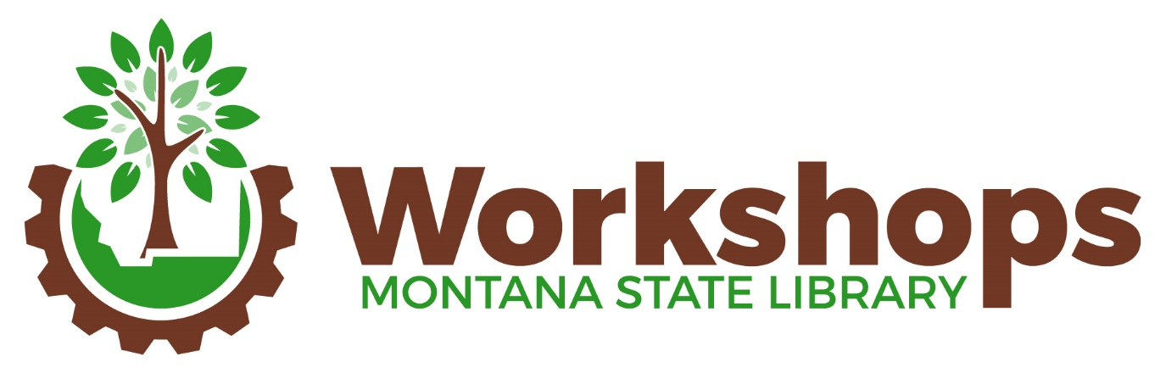
Bozeman, MT – Homewood Suites Hotel
MSL Workshops are presented with funding from the Institute for Museum & Library Services
Thursday, September 7th
Morning sessions
9 am – 10:30 am Board Room
Build a Digital Map: Hands on with Montana GIS resources
Jo Flick, Montana State Library
Just in time to include in your Summer Reading planning, this hands-on session using the MSL iPad lab is a model program that participants can easily replicate with kids and families utilizing the online mapping tools from the Montana State Library. A guide for presenting this activity at the library and with handout provided.
Participants will:
- access digital online maps
- learn to navigate and create customized maps

CE: 1.5 library services to the public

10:45 am 12:15 pm Board Room
A Tangled Web: Are Your Website & Social Media Working?
Jennifer Birnel & Jo Flick, Montana State Library
Participants will explore how they are perceived by non-patrons who know them only by what they can see online. Using the MSL iPads, participants will reconsider their library’s website, social media, and online interaction with potential patrons. We’ll review some exemplary models of ways that libraries are finding new audiences and providing and sustaining new services using the Internet. Participants will:
- implement at least one sustainable change to improve the library’s presence online

CE: 1.5 technology

9:00 am 12:15 pm Ballroom
Stumbling on Success: Library revitalization through community engagement
Christine McPhee, Okanagan Regional Libraries, Kelowna, British Columbia
The path to a fully engaged and community-centred public library is not a clear or easy one. Though a lot of work has been done to lay the groundwork for how to create a community led library, actually carrying that out is an iterative, messy, confusing and sometimes frustrating process. The rewards, however, are worth the time spent stumbling in the dark. This session uses examples of library revitalization in the Okanagan Regional Library system to ask the question – how can you change your library services to better reflect the needs of your unique communities. As library workers we have all spent time pondering our futures and wondering about the relevance of libraries in the digital age – but while we do this, we continue to offer service, support lifelong learning, and remain essential hubs for access and equality in our communities. By changing the focus from what might happen in the future to what we can create and enable right now, we empower ourselves, our institutions, and our communities to make the library we all need. Participants will:
- recognize methods that encourage community engagement and inform transformation of the library
- take away practical ideas for community-led library services

CE: 3 library administration

Afternoon sessions
1:15 pm – 4:30 pm Ballroom
Customer Service: It’s in our DNA, right?
Lauren McMullen, Montana State Library
Big Sky hospitality is renowned, but is your library as friendly and approachable as it should be? In this session, discover training available to help your staff learn to be more customer focused, improve techniques for good customer relations and explore ways to recalibrate your library space and staff to promote better service. Bring your best experiences to share. Participants will:
- practice techniques to foster positive customer service attitudes
- create customer service plans that will evolve and adapt to future needs
- acquire resources for further staff training

CE: 3 library services to the public

1:15 pm – 4:30 pm Board Room
Crucial Conversations
Paul LaChapelle, Montana State University Extension
Crucial Conversations teaches skills for creating alignment and agreement by fostering open dialogue around high-stakes, emotional, or risky topics. By learning how to speak and be heard (and encouraging others to do the same), you will begin to surface the best ideas, make the highest –quality decisions, and then act on your decisions with unity and commitment. A Crucial Conversation is a discussion between two or more people where the stakes are high, opinions vary, and emotions run strong. These conversations – when handled poorly or not at all – lead to strained relationships with dismal results. Crucial Conversations teaches participants how to:
- speak persuasively, not abrasively
- foster teamwork and better decision-making,
- build Crucial Conversation acceptance rather than resistance
- resolve individual and group disagreements

CE: 3 library services to the public

Stay in Bozeman for the Trustee/Director Training on Friday, September 8th at Bozeman Public Library.
Register by logging into the Montana State Library Directory.
Reserve your room at the Homewood Suites by August 7th to secure the state rate of $152/night. 406-587-8180. Alternate hotels nearby:
Hampton Inn
Holiday Inn
Best Western Plus Grantree
Days Inn
Comfort Inn
Bozeman Inn
La Quinta
Microtel Inn
Super 8
Rodeway Inn
Motel 6
Ramada
Fairfield Inn

For more information, contact: Jo Flick jflick@mt.gov

