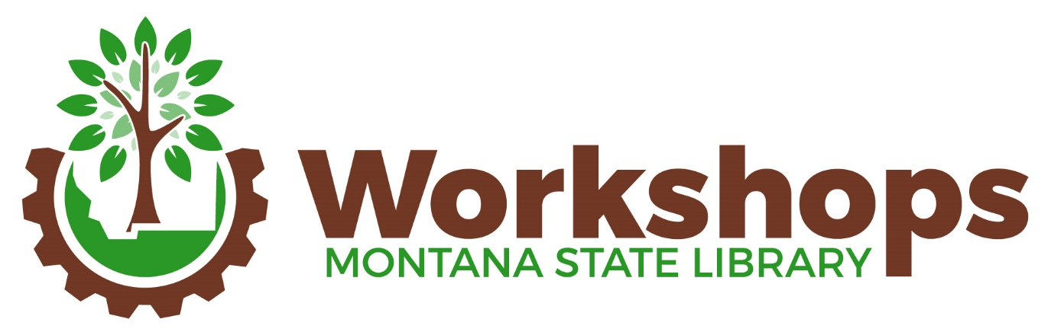
September 17 & 18, 2018
Fall
Double Tree Hotel, 2nd Floor
27 North 27th Street - Billings, MT
Registration Desk
Sunday, 9/16 First Floor lobby 4-6 pm
Monday, 9/17 2nd Floor 7:30 am – 4:30 pm
Tuesday, 9/18 2nd Floor 8 am – 1 pm

Create your own conference packet by printing what you like from the links below or downloading these documents to your computer or device. When you check in at the registration desk, you’ll receive a name badge, holder, and a schedule of the sessions you have registered for.
Sign up at the registration desk for group lunch or dinner. If you want to lead a group to a restaurant not on the list, ask to start a new sign-up.

Directions to the Hotel: http://doubletree3.hilton.com/en/hotels/montana/doubletree-by-hilton-hotel-billings-BILDTDT/maps-directions/index.html
Schedule at a Glance: http://docs.msl.mt.gov/learningweb/documents/EventTab/FallWorkshops2018Schedule.pdf
Session descriptions: http://docs.msl.mt.gov/learningweb/documents/EventTab/FallWorkshops2018Program.pdf
Speaker Bios: http://docs.msl.mt.gov/learningweb/documents/EventTab/FallWorkshops2018Bios.pdf
Lunch/Dinner options: http://docs.msl.mt.gov/learningweb/documents/EventTab/FW2018eateries.pdf
Application for OPI credit certificate:
http://docs.msl.mt.gov/learningweb/documents/EventTab/FW2018OPICreditForm.pdf

