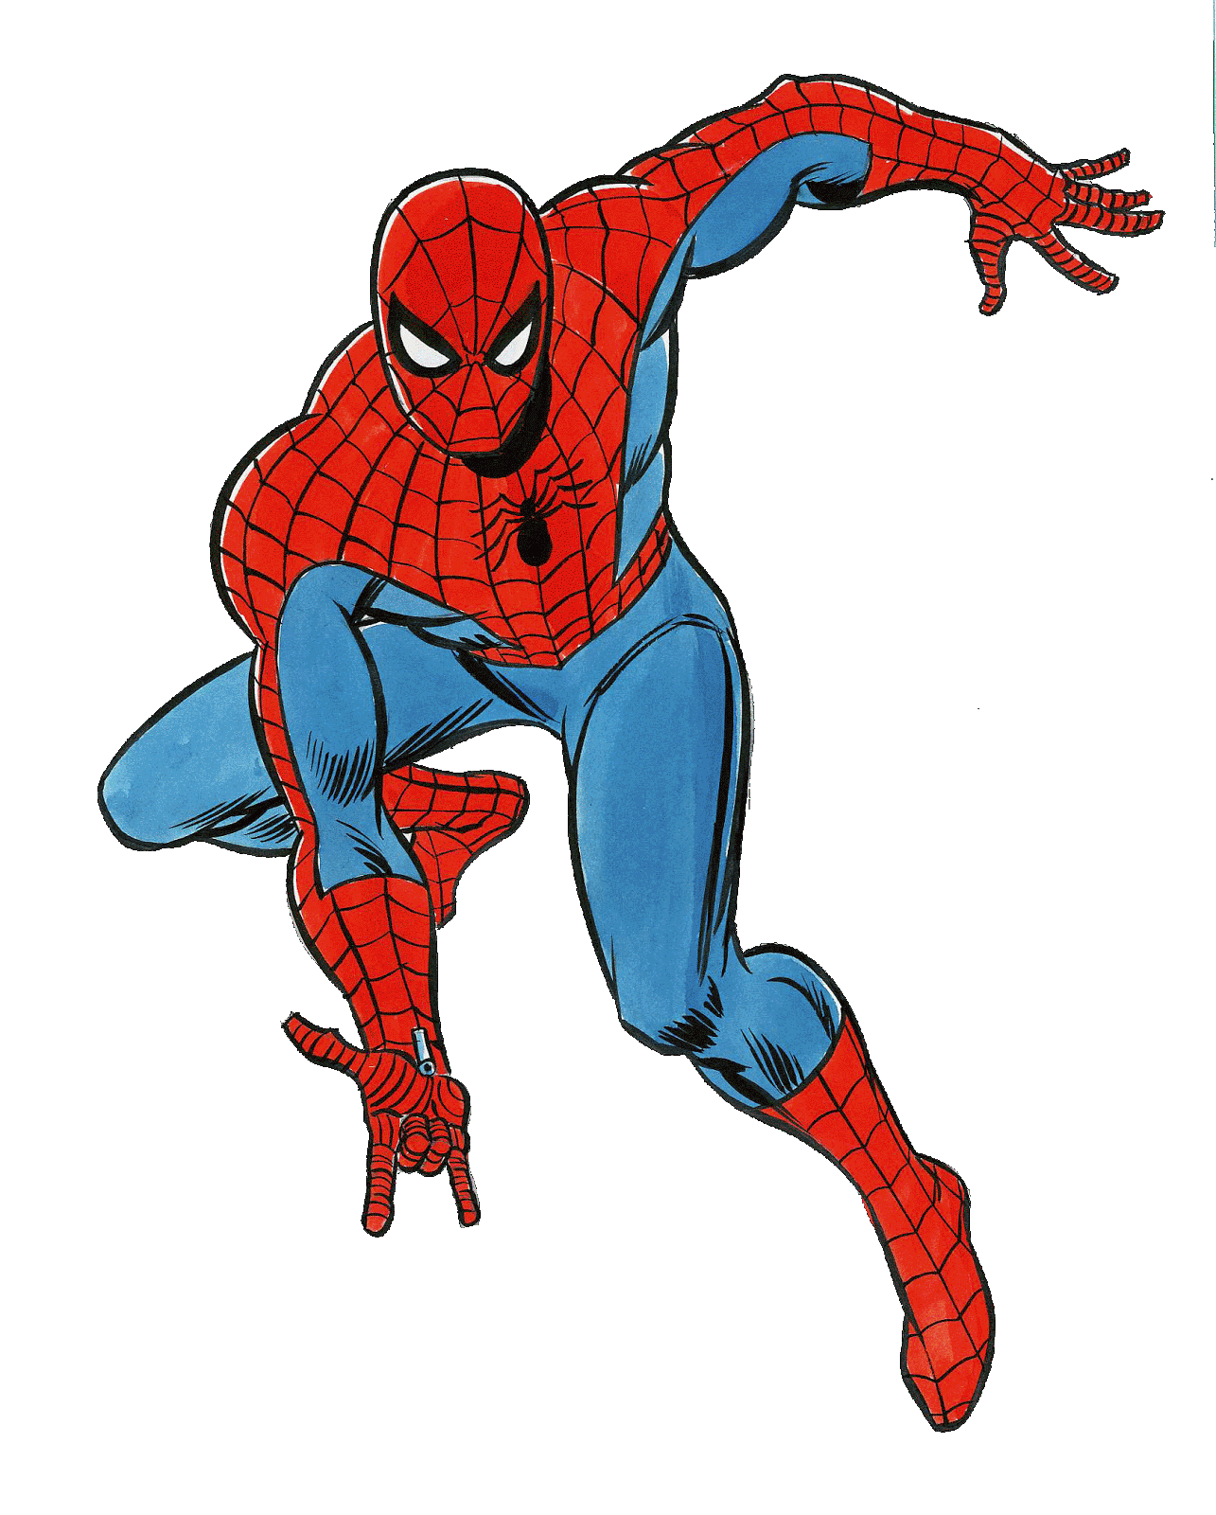
A Tangled Web
GREAT Web Sites – Spidey would approve!

- Kansas City Library https://www.kclibrary.org/ - Facebook, Twitter, Flickr, YouTube, Pinterest, RSS feed
- Missoula Public Library http://www.missoulapubliclibrary.org/ - Facebook, Pinterest, YouTube, Twitter
- Rosebud County Library http://www.rosebudcountymt.gov/LIBRARY_ROSEBUD_COUNTY/INDEX.html – Facebook
- North Lake County Public Library District – Polson http://northlakecountylibrary.org/default.html
- Butte-Silverbow Public Library http://buttepubliclibrary.info/
- Lewistown Public Library http://lewistownlibrary.org/
- Blackfeet Community College Medicine Spring Library http://library.bfcc.edu/
- Lincoln County Public Libraries http://www.lincolncountylibraries.com/

