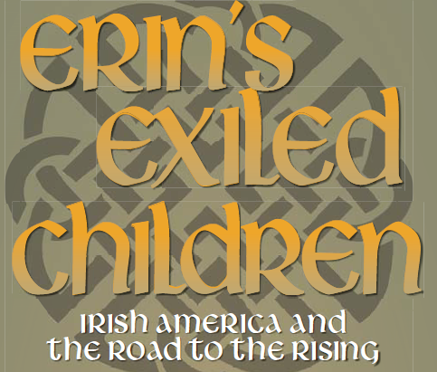
Erin’s Exiled Children: The Irish of America and the Making of Modern Ireland – is a traveling exhibit of 12 single-sided panels, approximately 3 ft. wide and 6 ft. tall each. Created by the Butte-Silver Bow Archives with in collaboration with the Ancient Order of Hibernians, the University of Montana, the Friends of Irish Studies in the West, and The Gathering to commemorate the centennial of the 1916 Easter Uprising in Ireland, this exhibit has enduring value as it relates the unique story of Irish immigration in Montana and the impacts that struggles in their homeland had upon Irish Americans.
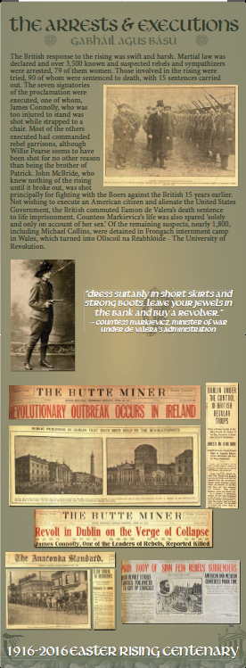
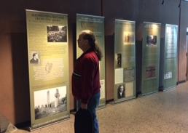
The Montana State Library is coordinating the tour by collecting applications to host, organizing a tour schedule and providing programming ideas for hosting libraries. The tour schedule will be set up so that libraries are able to pick-up and deliver the panels from place to place within a couple hours of driving. All participating libraries must make their own arrangements to transfer the panels from one location to the next by contacting the library scheduled before and after their exhibit time and determining transportation plans that are suitable to all parties.
The panels will be available to each participating library for one month. The panels are sequenced, but they do not need to be displayed all in the same room. Because they are single-sided, they may be placed against a wall, or back-to-back. Libraries are welcome to set up the display at another venue in their community, if they prefer, provided the panels are in a safe and secure indoor location. There is only one set of panels, and no funds for repair or replacement, so if they are damaged or lost, the remainder of the tour will be cancelled.
Participating libraries may learn more about the exhibit and what is involved in hosting the panels by viewing a MT State Library and Butte-Silver Bow Archives webinar scheduled for December 19th at 12:30 pm; register here: https://attendee.gototraining.com/r/4101042411221793281
Libraries may sign up to host the exhibit by completing this online form: https://goo.gl/forms/nI6S79VCtyNea7x62

