Divide Montana into TWO Congressional Districts
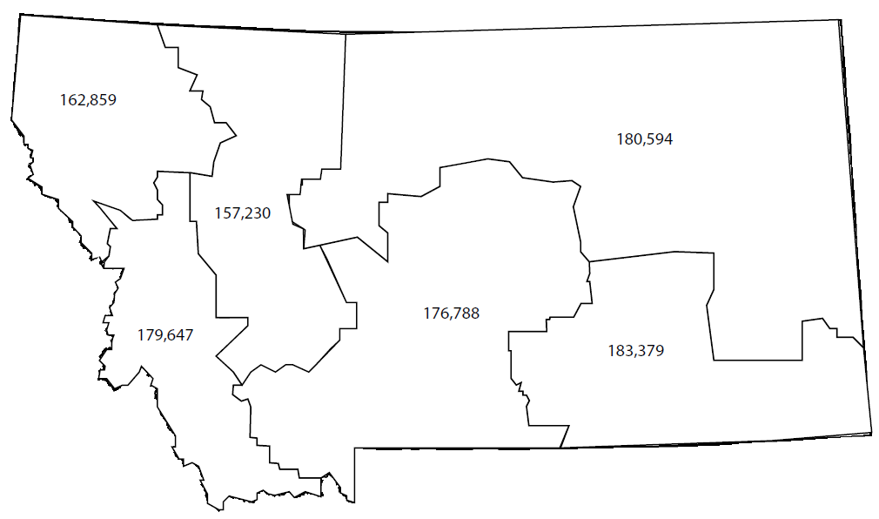
Instructions: Use two different colored crayons or higlighters to divide Montana into two districts with as close to an equal number of residents in each district as possible. The districts must be contiguous (that means that they are connected and not separated chunks.) Think about the physical size and population served in both districts, do they have similar interests and concerns? Does a division between the east and west make the most sense or would Montana be better served with the lines drawn another way?

Write a brief statement explaining why you think your districts are a good choice to represent Montana voters in the US Congress:

Go deeper:
You can also use this map of Montana counties: http://ftp.geoinfo.msl.mt.gov/Documents/Maps/Individual/20010118_570_2001_MTCounties.gif
And, this list of population figures for each county: https://www.montana-demographics.com/counties_by_population to try this activity with more data.

In actuality, congressional districts do not have to follow the boundaries of counties and are part of redrawing all voting districts in the state. This activity is a simplified version of the process intended to get people talking about it and considering all the implications of where those lines are drawn. Montana has a really good chance to recover a 2nd seat in the US Congress, if the 2020 Census is a complete count.

More on redistricting:
GeoCivics https://www.uccs.edu/geocivics/ from the University of Colorado at Colorado Springs, an online resource and specific materials for Montana
Get the Giant Map of Montana – a large room-sized floor map for a variety of geo-spatial activities. Comes in a large trunk on wheels with other materials and activity plan ideas: http://libraries.msl.mt.gov/lifelonglearning/giantmap

Help Montana get a COMPLETE Count – complete the form here: my2020Census.gov
Montana Census and Economic Information Center

